**Lesson 14: Scientific Notation**

**Do Now:**

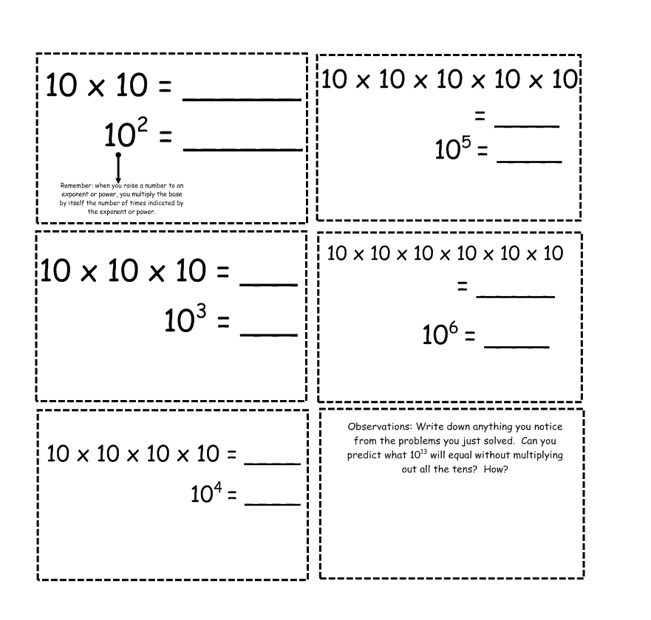

**Guided Notes:**

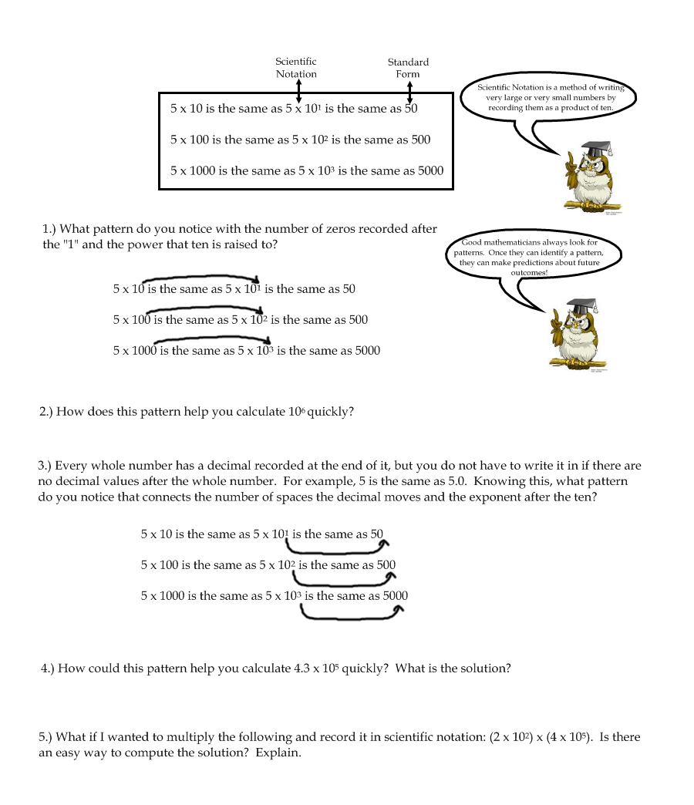

**Structured Practice:**

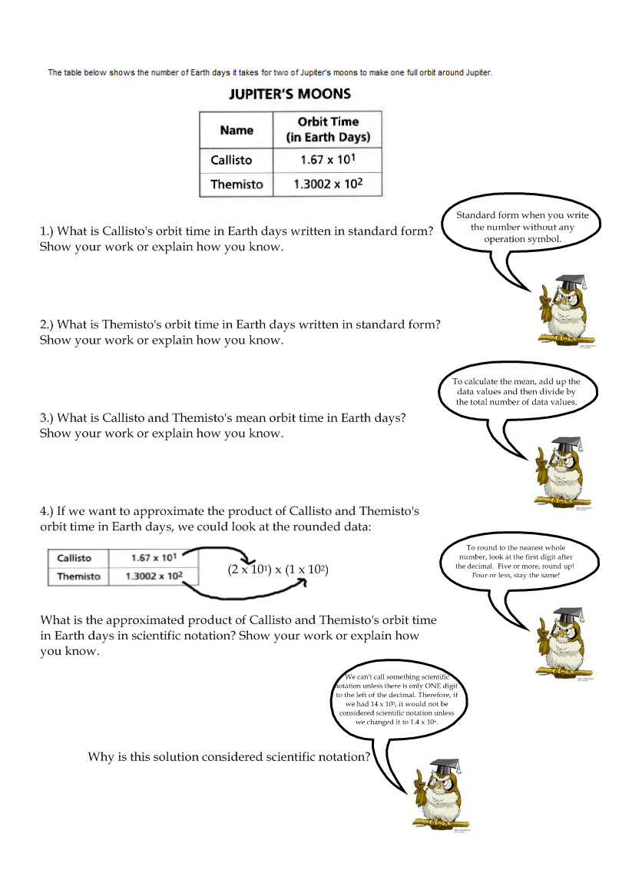

**Guided Practice:**

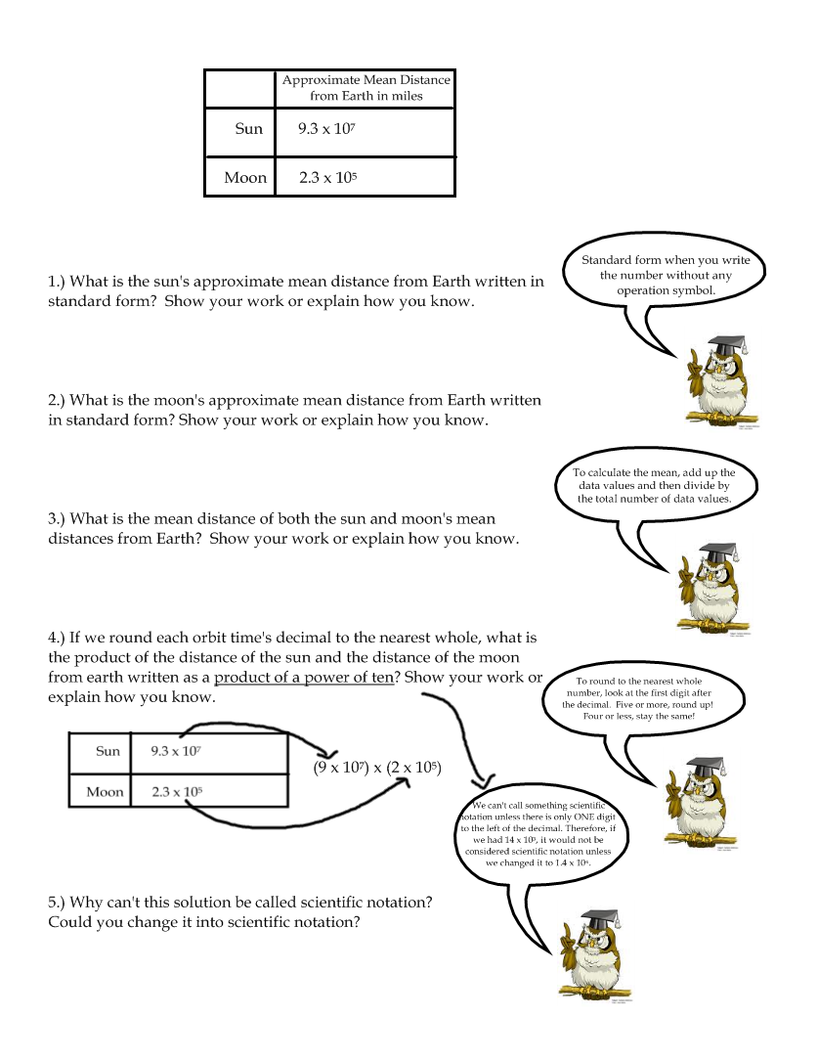

**More Practice**

* + 7 x109= Population of the world is around 7 billion written out as __________________
  + ______________= Approximate speed of light is 1080 million km per hour or 1,080,000,000 km per hour
  + 2.4 x105= Distance from the Earth to the moon is 240 thousand miles or ______________________ miles
  + ________________________= Distance from the Earth to the sun is 93 million miles or 93,000,000 miles
  + 3.99 x1013= Distance from the sun to the nearest star (Proxima Centauri) is _______________________ km
  + ________________________= Distance light travels in a year is less than 9.5 trillion kilometers, or exactly 9,460,528,400,000,000 km
  + 1.4 x108= Amount of water surface area on the Earth is 140 million square miles or _______________ square miles

For the following facts, try to ballpark (estimate) the correct number.

* + Approximate number of cells in the human body
  + Density of oxygen is 1332 millionths g per cc
  + Diameter of a grain of sand is 24 ten-thousandths inch
  + Mass of a dust particle
  + Mass of an electron
  + Length of the shortest wavelength of visible light (violet)

**Independent Practice:**

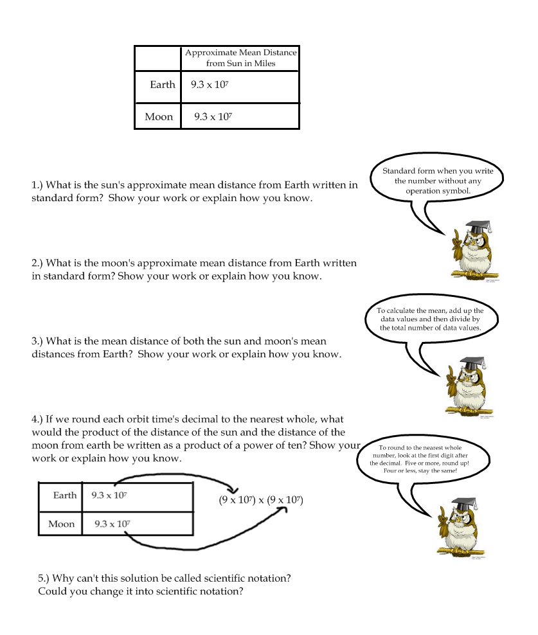

2. NASA recently released images of Pluto. Pluto is 3.67*109 miles away from the Sun. Write this in scientific notation.

3. Jupiter’s approximate mean distance from the Sun is about 4.84*108 miles. Divide that distance by the mean distance of the Earth from the Sun. The answer should be in scientific notation.